**CTS DIGITAL NURTURE - 4.0 JAVA FSE**

**WEEK 4 -** **Spring REST using Spring Boot 3**

**2.spring-rest-handson**

**Hello World RESTful Web Service**

PROGRAM:

**HelloController.java**

package com.cognizant.springlearn.controller;

import org.slf4j.Logger;

import org.slf4j.LoggerFactory;

import org.springframework.web.bind.annotation.GetMapping;

import org.springframework.web.bind.annotation.RestController;

*@RestController*

public class HelloController {

private static final Logger ***LOGGER*** = LoggerFactory.*getLogger*(HelloController.class);

*@GetMapping*("/hello")

public String sayHello() {

***LOGGER***.info("Start");

String response = "Hello World!!";

***LOGGER***.info("End");

return response;

}

}

(Use the already existing SpringLearnApplication.java and run the application:)

**SpringLearnApplication.java**

import java.text.SimpleDateFormat;

import java.util.Date;

*@SpringBootApplication*

public class SpringLearnApplication {

public static void main(String[] args) {

SpringApplication.*run*(SpringLearnApplication.class, args);

*displayDate*();

}

public static void displayDate() {

*@SuppressWarnings*("resource")

ApplicationContext context = new ClassPathXmlApplicationContext("data-format.xml");

SimpleDateFormat format = context.getBean("dateFormat", SimpleDateFormat.class);

try {

Date date = format.parse("31/12/2018");

System.***out***.println("Parsed Date: " + date);

} catch (Exception e) {

e.printStackTrace();

}

}

}

OUTPUT:

Open http://localhost:8080/hello

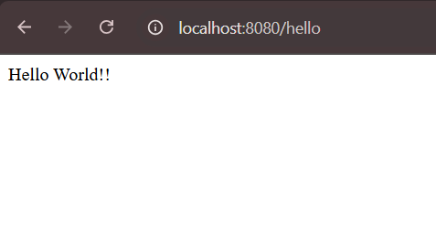

Inspect to see Status:

